Wandering in the Woods: Computer Simulation Game
Software Engineering A Practitioner’s Approach 9th Edition Supplement
Sai Ram Reddy Tippireddy and Likhitha Killari

Table of Contents
1.0 Introduction 2
1.1 Purpose 2
1.2 Wandering in the Woods 2
2.0 Process Model 2
3.0 Use Cases 3
3.1 Use Case 1: Begin the Game 3
3.2 Use Case 2: Play the Game 4
3.3 Use Case 3: Selection of Stage 4
3.4 Use Case 4: Visualizations of Statistics 5
3.5 Use Case 5: Replay the Game 5
3.6 Use case 6: Exit Game 6
4.0 UML Model 7
4.1 Use Case Diagram 7
4.2 Deployment Diagram 8
4.3 Class Diagram 9
4.4 State Diagram 11
4.5 Activity Diagram 13
5.0 Customer Journey Map 14
6.0 Personas 15
7.0 UI Mock-up 16
8.0 Testing Strategy 17

Introduction

Purpose
Mathematical computation and computer science are the subjects of critical thinking that requires skills among students to perform it efficiently. The higher possibilities of challenges in understanding math concepts along with computer science theories makes a student reluctant from dealing with it. The purpose of this project is to build a digital platform for student community that looks like a game but helps K-8 students to learn about the computation thinking, mathematical concepts and computer science.

Wandering in the Woods
The project named as “Wandering in the Woods” have been divided into three different levels based-on the grades of the student. The first level of this game gives a very simple challenge to the K2 grade students where one has to make few choices and observe the changes. The second level of the game or computer simulation will be slightly more complex for the students from Grades 3-to-5. In this 2nd level, the student has to overcome the additional challenges emerges after changes happens from making few choices. The third level of this computer simulation will be most critical for the gamers and it will be prepared for the students of Grades 6-to-8. Students in the third level would interact with big data to create graphs or meaningful visualizations that conveys their decision-making capacity as well as judgment.

Process Model
Process model describes the means of the internal process takes place within a business in the form of visualizations. This model is used with an intension to effectively manage the processes and reveals the mechanism to improve the process. It emphasizes a developer to continuously improve the process, which makes it a constant development activities. An evolutionary framework integrated with mechanism has been implemented to the design of this game’s interface. In order to make it flawless, an iterative approach has been adopted for applying the evolutionary framework in the software development lifecycle.
Initial Tentative Requirement

Specification
Creation
Validation
Starting Version
Intermediate Version
Final Version

Figure 1. Wondering in the Woods System evolutionary process model.

Use Cases
The following six uses cases were defined by the team and the client as the core system requirements for the delivery of working prototype. Note, this baseline functionality can be easily extended through the inclusion of more use cases as the project progresses. Each use case lists the name of the use case, primary actors, preconditions, description, and acceptance criteria.

Use Case 1: Begin the Game
Primary Actor: Student
Preconditions:
- The system used by a student should have the game application.
- Game application has been launched by the student.
Description:
The game is triggered by the student who opens the application and picks the choice to start the game. Once the game interface was launched, the system loads the resources needed and the main menu is ready to be displayed before the player. The gameplay environment commences when the student interacts with the screen. The system begins to play the game once the game is launched and presents the user interface in a state of readiness to interact further.
Acceptance Criteria:
- Successful launch of game application
- System loads the game interface without errors
- Accessibility of main menu of game by students

Use Case 2: Play the Game
Primary Actor: Student
Preconditions:
- Game application must be functional
- Choosing the Play option from Main menu by student.
Description:
This use case will start when the student clicks the play option on the menu to start playing the game. After picking the play option, the system shows the game screen which has a grid that depicts the simulation environment. The student moves through the grid and manipulates the elements of the game to do the movements and actions of the simulation.
Acceptance Criteria:
- Play option loads the game screen without any interruption.
- Exhibition of grid interface to the student.
- Begin interaction with the game environment by student.

Use Case 3: Selection of Stage
Primary Actor: Student
Preconditions:
- Game should begin
- Student must get multiple phases in the system
Description:
In this application, the student will choose a certain level and the gameplay will begin. The system has a number of stages, some of which are easier than others. The learner selects a level based on his/her preference and level of learning. Once the stage has been chosen, the system loads the suitable grid and playing environment that is related to that stage
Acceptance Criteria:
- Student should be able to see the displayed available stages.
- System permits student to choose the level of game.
- Selected phases must load correctly in the interface of game.

Use Case 4: Visualizations of Statistics
Primary Actor: Student
Preconditions:
- Student should be familiar of at least to play one round of the game.
Description:
The given use case enables the student to see the statistics created in the course of the gameplay. Various parameters are captured by the system and they include movements, actions and results obtained in the course of the game session. The student may also view his or her performance through the option of statistics after playing the game. These statistics are presented in the system in the form of graphs or numbers.
Acceptance Criteria:
- Statistics are created after the play is completed.
- The system exhibits the performance data efficiently.
- The system must have review option regarding their gameplay results.

Use Case 5: Replay the Game
Primary Actor: Student
Preconditions:
- One game session must have completed at least once.
Description:
This application enables the learner to restart the game upon completion of a session. The student can then select the replay option after completing the game round and showing the statistics. The system re-initiates the game interface and gives the student the opportunity to start another gameplay session either with the same or a different stage.
Acceptance Criteria:
- Replay option should be available after a game session ends.
- System must be capable of restarting the game.
- System allows students to play the game multiple times.

Use case 6: Exit Game
Primary Actor: Student
Preconditions:
- The system or application should be functional.
Description:
In this application, the student leaves the game when he/she decides to quit playing the game. The student chooses the exit button of the game window or menu. When the exit command is issued, the system will come to an end of the current game session and the application window will be closed.
Acceptance Criteria:
- System should provide an exit option to the players (students).
- System safely eliminates the session of game.
- Game window closes successfully.

UML Model

Use Case Diagram

Student
Grade 6-5 Group
Grade 3-5 Group
Grade 2 Group Student

Start the Game
Play the Game
View Statistics
Replay Game
Move Diagonal
Change Grid
Move Random
Exit Game
Choose Stage
Play Challenges
Test Varieties of Wandering technique

Figure 2. Use Case Diagram for the Wondering in the Wood Game System showing the six use cases for the project.

Deployment Diagram

Student

Keyboard/Mouse

Student Computer

Game Interface Module

Game Logic Engine

Statistics Generator

Local Storage
Game Data/Statistics

Figure 3. Deployment diagram for the Wandering in the Woods System.

Class Diagram
The class diagram for the core system of the Wandering in the Woods is depicted in Figure 4. The classes in the diagram are described below the figure.
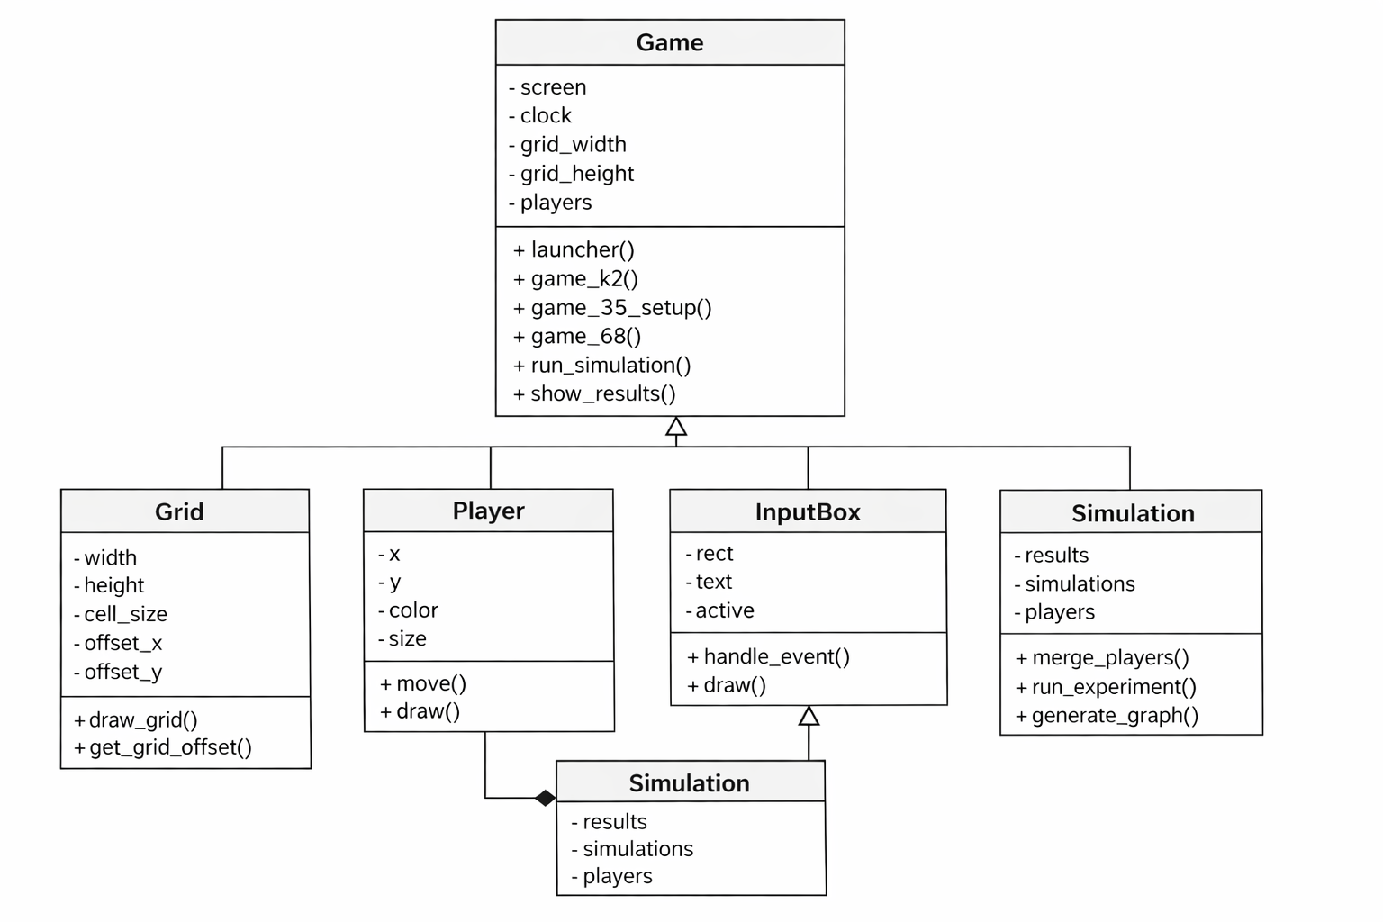
Figure 4. Class diagram for the Wondering in the Woods System

Class Responsibilities
The Wandering in the Woods simulation is designed modularly with various classes having specific duties in the system. Related data and behavior are contained in each class, enhancing the organization, readability and maintainability of the code. The main classes of the system are Game, Grid, Player, InputBox and Simulation.
1. Game Class
Game class is charged with managing the running of the application in totality. It is the main controller that handles various modes of the game, user interactions, and the change of screens.
This class initializes the game environment such as the graphical representation, game clock and background music. It is also in charge of the movement on the three educational levels: K2, Grades 35, and Grades 68.
As well, the Game class organizes the process of the simulation, by calling the required functions to initiate simulations, gather results, and show the results in the form of graphs and statistics.
The main duties are as follows:
- Introduction of the application and presentation of the main menu.
- Managing levels of the different game.
- Managing the process of simulation.
- The presentation of results and statistics of the experiment.
- Dealing with general user interaction and screen.
2. Grid
The Grid object is an imitation of the forest setting in which the wanderers travel. The forest is modeled as a rectangular grid which is divided into rows and columns. The grid squares are used to hold possible positions where a player can move.
The calculation of the size and location of the grid and drawing it on the screen is the duty of this class. It also decides how the grid will be positioned in the game window in order to make sure that the playing area is centered well.
Key responsibilities include:
- Saving grid dimensions (width and height).
- Computing grid offsets of centered display.
- Splashing the lines in the screen.
- Coordinate system used by the players: Player coordinate: This defines the coordinate system in which players move around.
3. Player Class
The Player is a character that symbolizes a forest wanderer. All the players are placed on the grid and move randomly in the simulation.

The class holds the details of present position, color and size of the player. It also stipulates the movement of the player on the grid and the visual representation of the player on the screen.
The players move randomly in four possible directions; up, down, left and right. Players that are on the same cell become part of a group and they move together.
Key responsibilities include:
- Saving position of players (x and y position)
- Controlling movements of players in grid boundaries
- Display of a player on the screen
- Rewarding merging behavior during players meeting.
4. InputBox Class
InputBox is a class that deals with input fields that are graphical and are meant to deal with the user. It gives the user an option to input parameters which include, grid size, the number of players, and the number of simulations.
This class is used to process keyboard events, maintain a record of whether the input field is active or not and update the text that is displayed. It also makes sure that input field could be drawn and revised dynamically in the graphical user interface.
Key responsibilities include:
- Processing keyboard user input
- Managing text input fields
- Active and inactive monitoring of the input boxes
- Making input fields of the graphical interface render.
5. Simulation Class
The Simulation class handles the logic of the experiment of the program especially in the experiment mode of Grades 6-8. It has the mandate of conducting various simulation trials and gathering the data that comes as a result of such trials.
In every simulation, players are randomly walking around until they encounter each other. The simulation notes how many movements it takes all players to unite in one fold.
Once several simulations have been run, the Simulation class runs the acquired data and calculates previous statistical values of the shortest run, the longest run and the average run. It also produces graphical forms of the results to enable the student to analyze pattern and trends.
Key responsibilities include:
- Conducting simulation trials
- Monitoring the outcomes of simulation
- Handling the relations between the players and combining behavior
- Creation of statistical summaries.
- Preparation of graphical models of experiment outcomes.

State Diagram

Start
Start Game

Main Menu
Exit Game
Select Stage

Play Game
View Statistic

Replay Game
Main Menu
End

Figure 5. State diagram for the Wondering in the Woods System

The high-level behavior of the Wandering in the Woods educational game system is shown in the state diagram shown in Figure 5. It indicates the large states that the system passes as the system works in the normal condition and how the system shifts to the large states developed depending on the actions that the student is taking.
The system starts with the Start State at which the student opens the game application. On leave of this state, the system moves to the Start Game State where the game interface is ready and the system sets up the environment to play the game.
Once the system has been initialized, it will proceed to the Main Menu State. The student in this state has various choices to make which include choosing a stage to play or leaving the game. In case the student opts on the stage selection option, the system will switch to the Select Stage State where the student may opt on a selection of the stage or level depending on the level of the difficulty of the simulation.
After a stage has been chosen, the system goes to the Play Game State. The student also moves in the simulation by performing movements within the grid-based environment in this state. The system keeps working and executing the actions of the player and keeps on updating the game environment.
Upon the play through, the system moves to the View Statistics State. At this state, the system will show the performance outcome of the student like the number of moves performed, and other game playing outcome.
The system next goes to Replay Game State whereby the student has the option of playing the game again. In case the student chose to replay, the system is directed back to the Main Menu State to allow the student to choose another stage or launch the game again.
Alternatively, the student can select the Exit Game State in the main menu. In this event, the system will be shifted to the End State where the game session is ended and the application is closed

Activity Diagram
Figure 6 below is a high-level description of the high-level behavior of the Wandering in the Woods game system. It shows the sequencing of operations carried out by the system and the student in the process of the game play. After following the flow outlined in the state diagram above, the system starts as the student opens the game application after which the system starts the program and loads the main menu, in which the student will be presented with the choice of either starting the game, selecting a stage, or quitting the application. After the menu is loaded, the student chooses a stage based on the desired level of difficulty and the system switches the play game activity, where the game environment and grid structure are shown on the screen. The student is involved in the system as it plays and as they do it, the system tracks and records the movements that the student does in the game. The system processes these movements to update the game environment to find out the progress of the student in the simulation. Once the gameplay has been finished, the system will generate game statistics, such as the amount of moves and the performance of the student in general, which is presented in the view statistics activity. At this stage the student can opt to replay the game or to leave the application, in the second case, the system goes back to the menu or to select stage activity which initiates a new playing session, and in the first case, the system will end the program and will enter to the last state, which completes the activity flow of the game.

Start
Launch Game

Load Menu

Fork

Exit Game
Select Stage

Play Game

Record Moves

View Statistics

Decision

Replay Game
Exit Game
Figure 6. Activity diagram Wandering in the Woods.

Customer Journey Map
The customer journey map of the Wandering in the Woods game system was elaborated to get a deeper insight into the learning process of the students who worked with the mathematical simulation game. The student aims to have a feel of the game environment and enhance the knowledge of mathematics by navigating the grid-based simulation and passing through various levels of the game. When the student opens the game, the first thing to be seen on the screen is the main menu where the student can either start the game, pick a stage, or leave the application. The student then picks a right stage according to the level of difficulty and starts engaging with the grid environment by making movements in the simulation. During the gameplay, the system will capture the motions and acts of the student and modify the game environment. Following the play session, the system presents the statistics which indicate the performance and progress of the student. These touch points are used to bring out the important interactions between the student and the system as the student strives to attain the learning objectives of the game. The trip will also enable the student to restart the game to play again to increase the performance or leave the application after viewing the outcome, which will be a continuous and involving learning process.
View Result
Play Game
Select Stage
View Main Menu
Launch Game

Figure 7. Customer journey map for the Wandering in the Woods system.

Personas

Figure 8 provides one of the personas of the Wandering in the Woods educational game system. Creation of personas assists the designing team to have a clearer idea of the nature, objectives and difficulties of the users that will relate the system. It is a project that is mainly used by students who engage the game in learning mathematics through simulation and interaction. Persona development enables the developers to put in mind user requirements, capabilities, and learning orientations as they develop the system. In particular, a student who utilizes the game might possess varying degrees of mathematical knowledge and might need a simple interface and instructions on how to operate the system. The design team then needs to put into consideration the issues of usability, learning support and engagement so that the game would offer the player a good learning experience. New personas can also be developed depending on the development of the project to accommodate the different kind of students and learning abilities who might use the system.
 | Studying in Grade 7 as a middle school student.  Is 12 year old student enjoys solving puzzle and playing simulation-based games.  Interested in learning mathematical concepts through visualizations and interactive tools. | Used to learn the math concepts through playing games, but the process is simple.  Wants to enhance the computational skills through playing games.  System should provide clear instruction and feedback to support the understanding of complex concept.
Alex

Figure 8. Persona to evaluate the Wandering in the Woods system.

UI Mock-up
The Wandering in the Woods educational game system has an initial user interface mock-up that is shown in Figure 9. The interface is the key gameplay display, upon which the student performs interactions with the simulation environment. The next features are the title of the game at the top of the screen and the details of the stage the player is on as well as the number of moves made. The main section of the interface is the grid-based woods environment whereby the green triangles represent the trees that devise the boundaries of the forest, the walkable areas of the woods are the small square boxes, and the smiley icon is the human character walking in the woods. The gamer moves in these squares avoiding the trees and investigating the forest zone. Directional controls are also available at the bottom of the interface to enable the player move either up and down, left and right in the grid. Other choices like replaying a game, seeing statistics and quitting the application are also provided. These interface elements form an interactive setting whereby the student is able to interact with the woods simulation as they monitor the evolution and manage the game action.

Wandering in the Woods
Stage: 2

Move : 17

Start
Pause
Back

Figure 9. User interface mock-up for Wandering in the Woods system.

Testing Strategy

The Wandering in the Woods game system testing strategy will be easy and largely rely on manual testing. Every piece of code will be closely checked and analyzed before being implemented to make sure that the program acts as it is supposed to. The testing will be done by testing the functionality of the game like the ability to select the stage, move in the grid, generate statistics and leave the system to ensure that the system does not have any malfunction.

